Softuniada 2019

Grid Voyage
Doctor Sanity’s pet pokemon – Slifer, is training his sense of direction with a game that Doc designed for him, called Grid Voyage. You should help Slifer, as he is not the smartest pokemon in existence. Try to write an algorithm which simulates the Grid Voyage game.
You will be given N – an integer. You must create a 2-D matrix of integers with N rows and N columns, each cell with value – 0. You will then receive the coordinates of the start point.
Afterwards, you will start receiving lines, containing coordinates of a destination point, the initial direction (left, right, up, down) and current stamina. You must reach the destination point doing a grid-based movement, only changing directions when you run out of stamina.
- You consume 1 stamina per step (per cell movement).
- When you run out of stamina, you MUST change the direction and reset your stamina.
- You must increase the value of each cell you step on with 1.
Example: Initial position – [0, 0].
First destination [2, 2]. Initial direction – down. Stamina – 2.
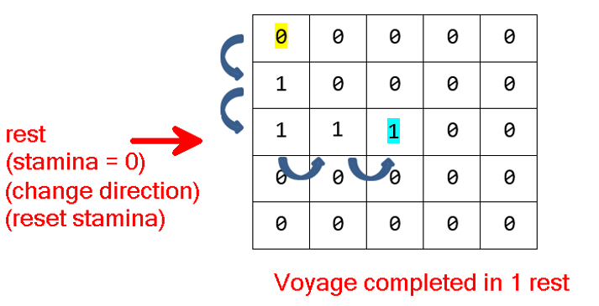
Slifer is always looking for the fastest path, which means that he should always move in directions, towards his next destination.
Slifer is fat – he can ONLY turn left or right. He CANNOT completely turn around in a reversed direction.
Slifer possesses a bit of intellect – if he is in a dilemma (he can go several directions, and all of them are leading to his target), he will try to turn LEFT first.
- If he cannot turn left (not enough space in matrix, to make the needed steps before the next change in direction), he will try to turn right.
- If he can turn neither left, nor right, he will deem the current Voyage – impossible and return to his previous position. In this case, there should be NO cells affected by increased value.
If it is possible to reach the destination, you must print how many rests (how many times you’ve ran out of stamina and you’ve changed direction) Slifer took to reach it. If it is NOT possible to reach the destination, you must print "Voyage impossible".
When you receive the command "eastern odyssey", the input sequence should end, and you should print the whole matrix.

Input
The input consists of several input lines:
- On the first input line you will receive N – the dimensions of the 2-D matrix.
- On the second input line you will receive X and Y, separated by a space – the initial position of Slifer.
- On the next several input lines you will receive coordinates of a destination point, a direction and stamina in the following format: {destinationX} {destinationY} {direction} {stamina}
- When you receive the command "eastern odyssey", the input sequence should end.

Output
As output you must print:
- For every voyage:
  - If it is possible, the number of rests it took to reach the destination point.
  - If it is NOT possible – you should print "Voyage impossible".
- At the end of the program:
  - The whole matrix – each row on a new line, each column separated by a space, from the others.

Constraints
- The integer N will be in range [0, 50].
- The coordinates of the initial point and destination points will always be VALID and inside the matrix.
- The directions will always be valid.
- The stamina will always be in range [1, 50].

Examples
Input | Output | Comment
5  0 0  2 2 down 2  4 4 right 1  eastern odyssey | 1  3  0 0 0 0 0  1 0 0 0 0  1 1 1 1 0  0 0 0 1 1  0 0 0 0 1 | First Voyage:  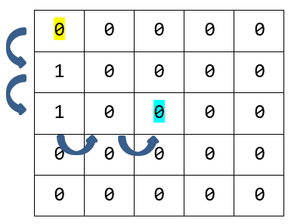  Second Voyage:  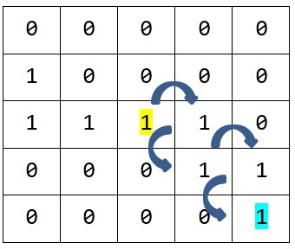  The stamina is 1 this time. We must change direction after each step.
7  3 3  5 5 left 2  6 6 right 2  eastern odyssey | 5  Voyage impossible  0 0 0 0 0 0 0  0 0 0 0 0 0 0  0 0 0 0 0 0 0  0 1 1 1 1 1 0  0 1 0 1 0 1 0  0 1 1 1 0 1 0  0 0 0 0 0 0 0 | 